Name: _______________________________Period: ____

Soda Molarity Lab

Learning Target:
____________________________________________________________________________________________________________________________________________________________________________________________________

Objective:
____________________________________________________________________________________________________________________________________________________________________________________________________

Pre Lab Questions:
- Determine the molar mass of fructose (C₆H₁₂O₆).
- Using the Nutrition Facts below and calculate the molarity of each of the unknown sodas.

Nutrition Facts

* all Nutrition Facts are for 20 oz. bottle.
 | 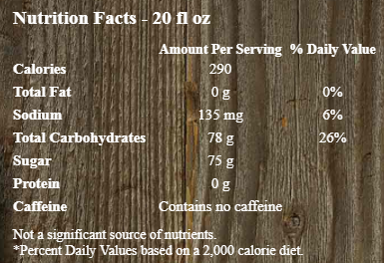 | 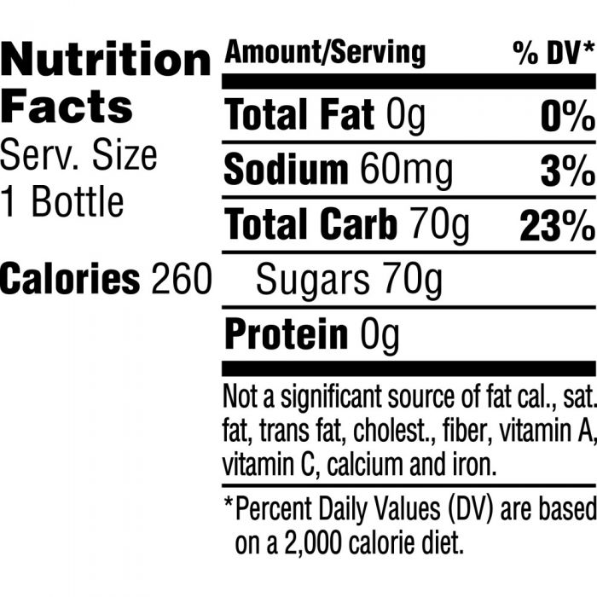 | 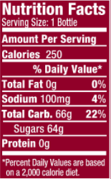
Grams of Sugar
Moles Sugar
Liters of Solution
Molarity (M)
Show Work

Procedure:
- Get your sample of unknown soda from Mr. Schultz.
- Find the mass of an empty 50 mL beaker. ________________________
- Determine how many mL of soda are in your sample using graduated cylinder. ___________________ mL soda
- Pour your 15 mL sample of soda into a 50 mL beaker.
- Set up your Bunsen burner and start evaporating your water.
- Heat your soda until NO MORE STEAM OR CONDESATION IS OBSEVERED.
- Allow your beaker to cool off.
- Record the final mass of your beaker and contents. _________________ grams
- Find the mass of the contents (sugar) in your sample of soda. __________________ grams
- Fill your beaker half full of water and reheat the solution until all the sugar is dissolved in solution. (SHOULDN’T HAVE TO BRING IT TO A BOIL)
- Pour the contents down the drain and rinse your beaker.
- Clean up your lab station.

Calculations:
- Calculate the molarity (M) of your sample of soda.
- Based on the data provided in the table above and your experimental calculation of molarity which soda did you have? Explain how you determined the answer.
- Copy down the class data for your unknown only.
Unknown #1 | Unknown #2 | Unknown #3
AVG | AVG | AVG
- Based on your calculations and the nutritional facts calculate your percent yield.
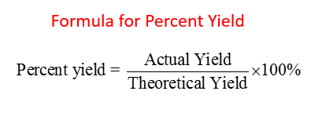

- Using the known molarities of the soda and your results calculate the percent error for the experiment
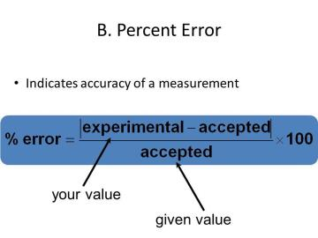
- What are 3 possible causes for your calculated Molarities to be incorrect?

Challenge Question

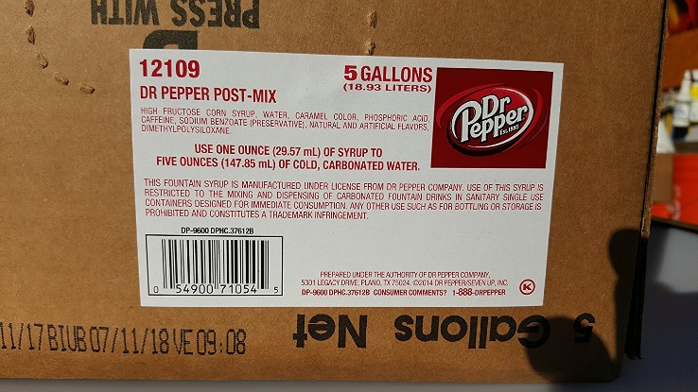
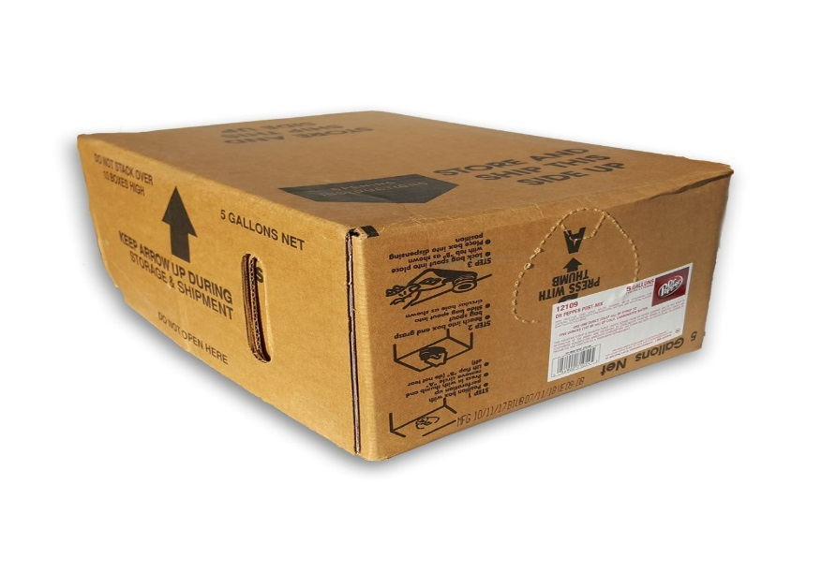

Fountain soda doesn’t come pre mic

